Date | Activity | Location | PL/APL | Leader | Notes
Thursday  22/04/10 | Bike hike | Dee Why to Narrabeen | All PLs |   Teddy | Time to get those bikes out. Make sure they’re ready to ride. You will need lights, helmet and sensible clothes for evening riding. Those who don’t want to ride we have a walk for you. Scarf only.
Sunday  25/04/10 | ANZAC Day march | Brookvale | All PLs |   Meet at 6:30am, Brookvale School. Full uniform, washed and ironed and black or brown school shoes, polished.  Makara | 
Thursday  29/4/10 | Hike prep | Hall | Belinda |   Makara | Bring your pack fully packed for the hike for check & weigh. Scarf only
Week end  30/4/10-2/5/10 | Scouthike | State Forest | All PLs | 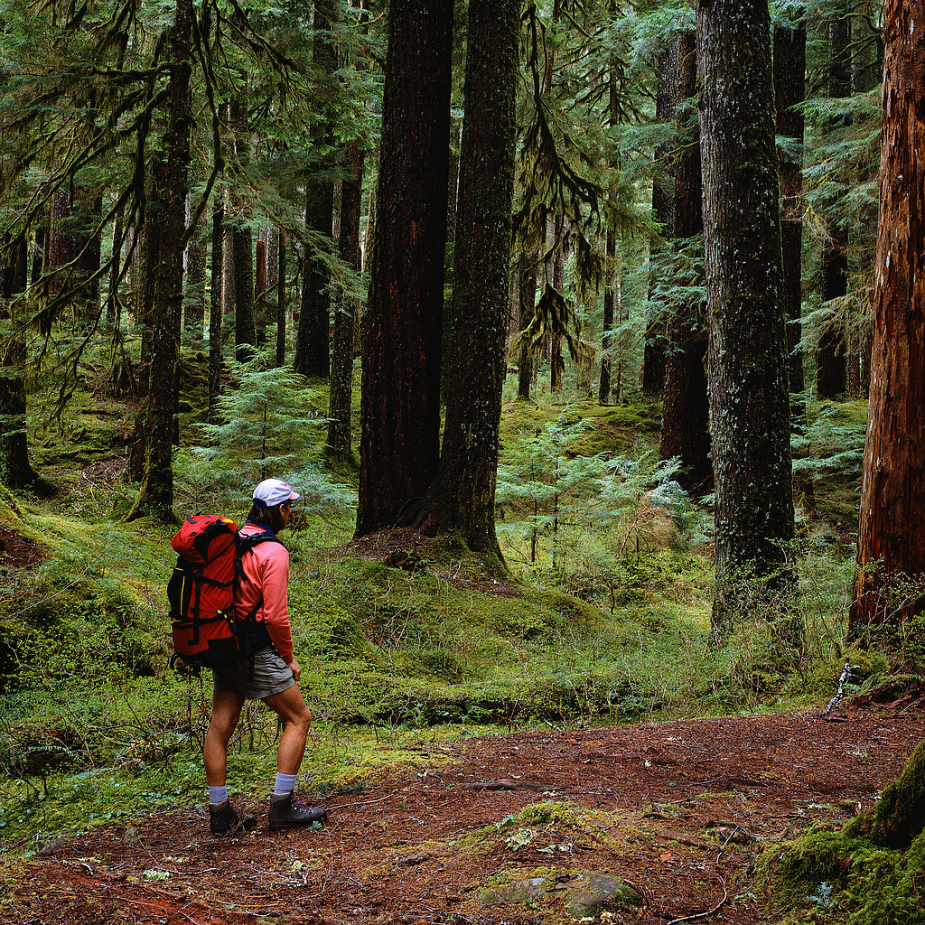  All  Changes to Patrols by 18/4/10. Payment by 22/4/10 | Ready for a fun filled weekend in the forest! Scarf only.
Thursday  6/5//10 | Return Gear from Scouthike  Rockclimbing | Meet at hall then walk to NBRH  Brookvale | All PLs | 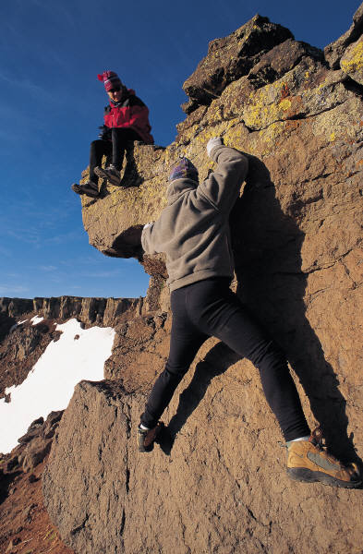  Teddy | All gear must be returned from Scouthike before we can go climbing!  No uniform.
Friday  7/5/10 ?? | Movie  Premier night  Possible fundraising opportunity | TBC | Anyone who wishes to take this on |   Teddy | This activity has yet to be confirmed.  Fancy Dress.  Maybe hall awake over!
Saturday  8/5/10 | JOTT (Jamboree on the Trail)  Hike | TBC | All PLs | Makara  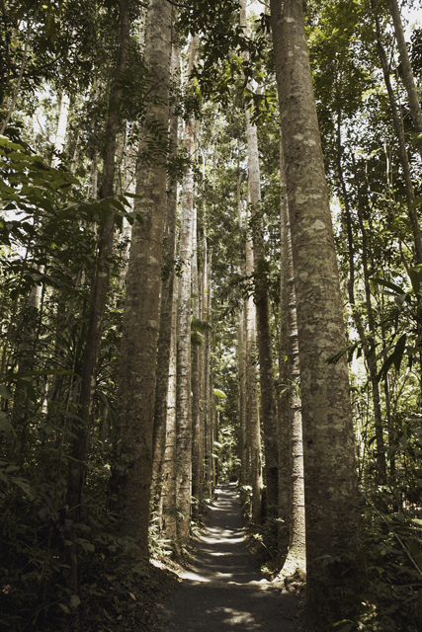 | Scouts all over the world will be hiking on this day so will we but NO mountains! Scarf only.
Thursday  13/5/10 | Abseil Theory | Brookvale Hall | Kiri | Makara  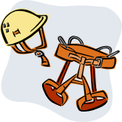 | Get ready for abseiling. Learn about the gear and other things you need to know
Weekend  15/5/10 | Abseil Day  TBC | TBC | Jamie | 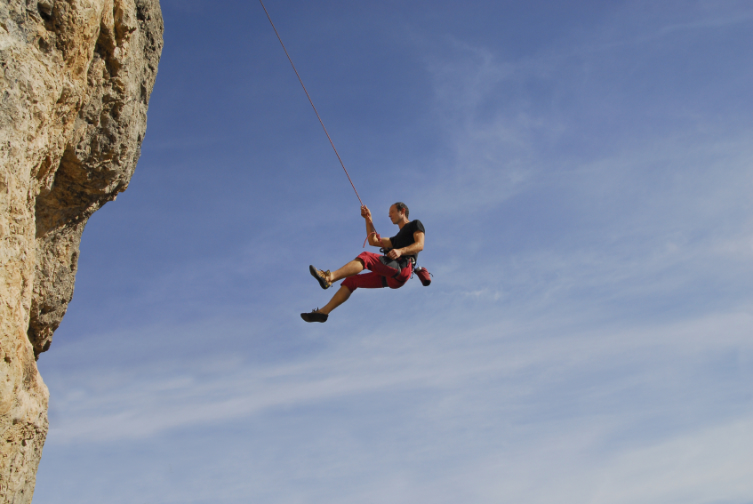  Makara | TBC Dependant if we can book this weekend
Thursday  20/5/10 | Badgework/testing | Hall | Belinda | Teddy   | Don’t forget your green book! Uniform.
Thursday  27/05/10 | Cook dinner | Manly Dam | All PLs | 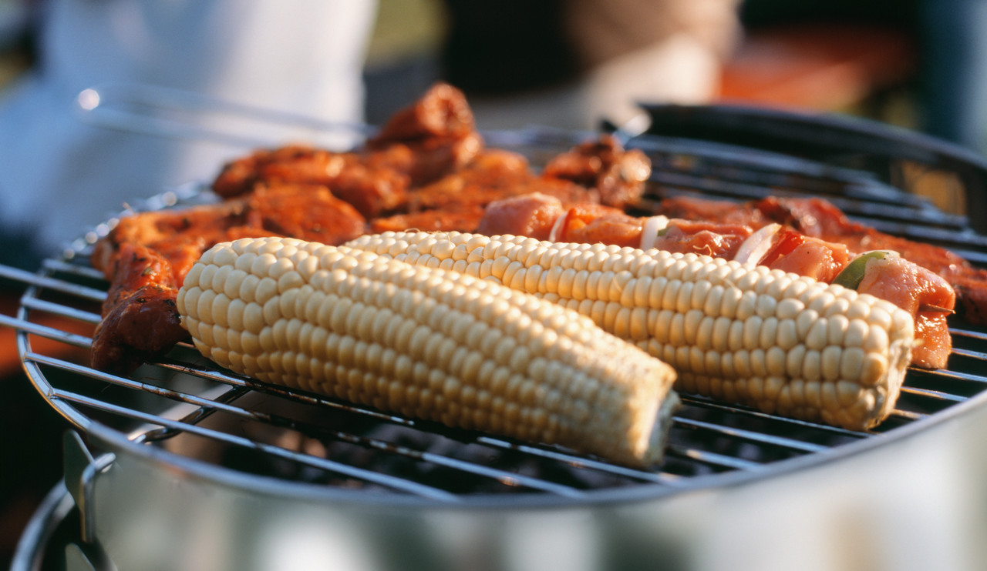  Makara | Tonight don’t eat dinner before scouts. Practice dinner for District camp. Scarf only
Thursday  3/6/10 | Intoduction to Scuba Diving | Frog Dive, Willoughby | All PLs | 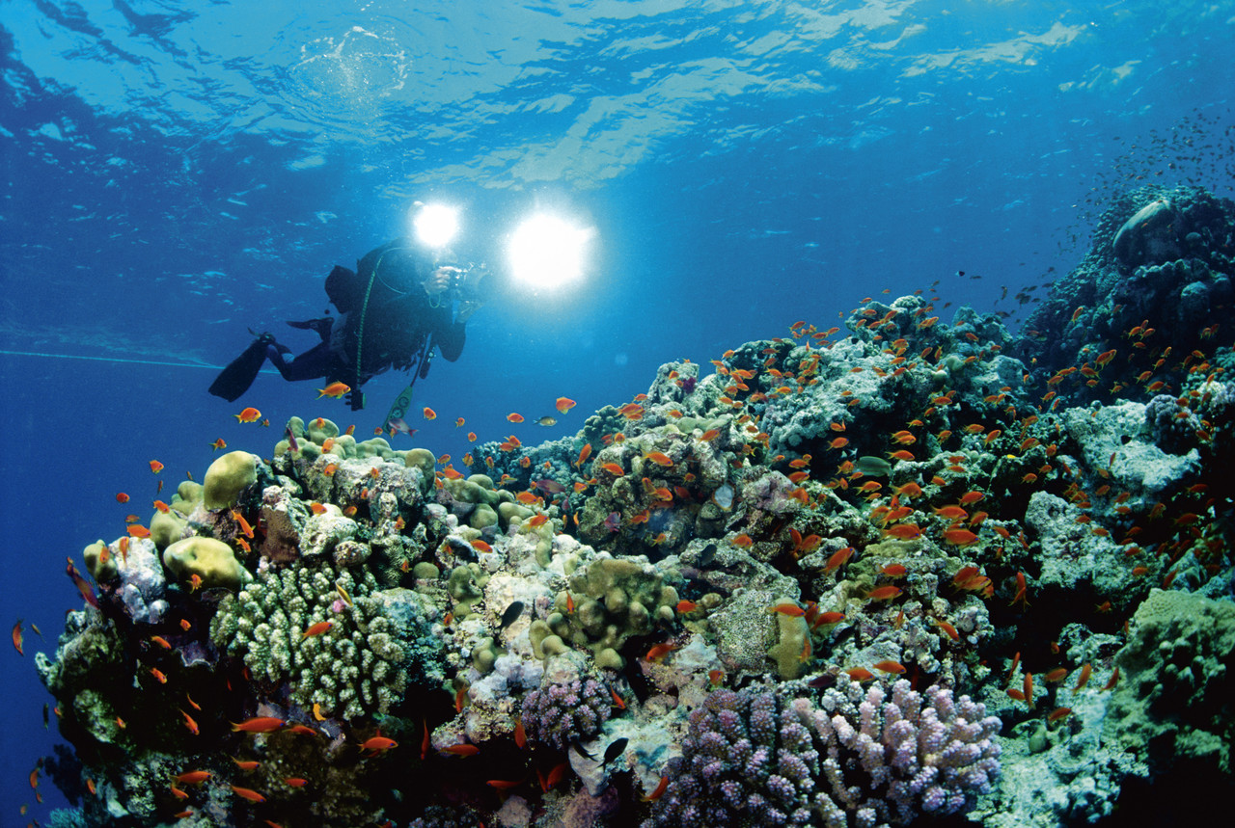  Makara | There will be 2 permission notes for this one and the cost will be $30. Scarf only.
Sunday  6/6/10 | Junior First Aid Course | Barra Brui Scout Hall,  St Ives | All under 14yrs of age | Makara. Full uniform.  Applications need to be in by 13th May | A good way to get all you first aid badge work done and a First Aid Certificate as well
Thursday  10/6/10 | Camp prep | Curl Curl | Kiri |   Teddy | Make sure all your food and gear is in order and packed. Scarf only
Weekend  11/6/10-14/6/10 | District camp | Crosslands | All PLs | 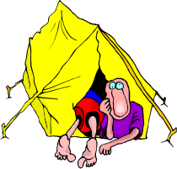  Makara | 3 night competition camp. In Patrols. Best Patrol wins! Full uniform to & from camp.
Thursday  17/6/10 | Badgework/Testing | Hall | Jamie | Teddy | Don’t forget your green book. Uniform.
Thursday  24/6/10 | Campfire night | Manly Dam | All PLs | 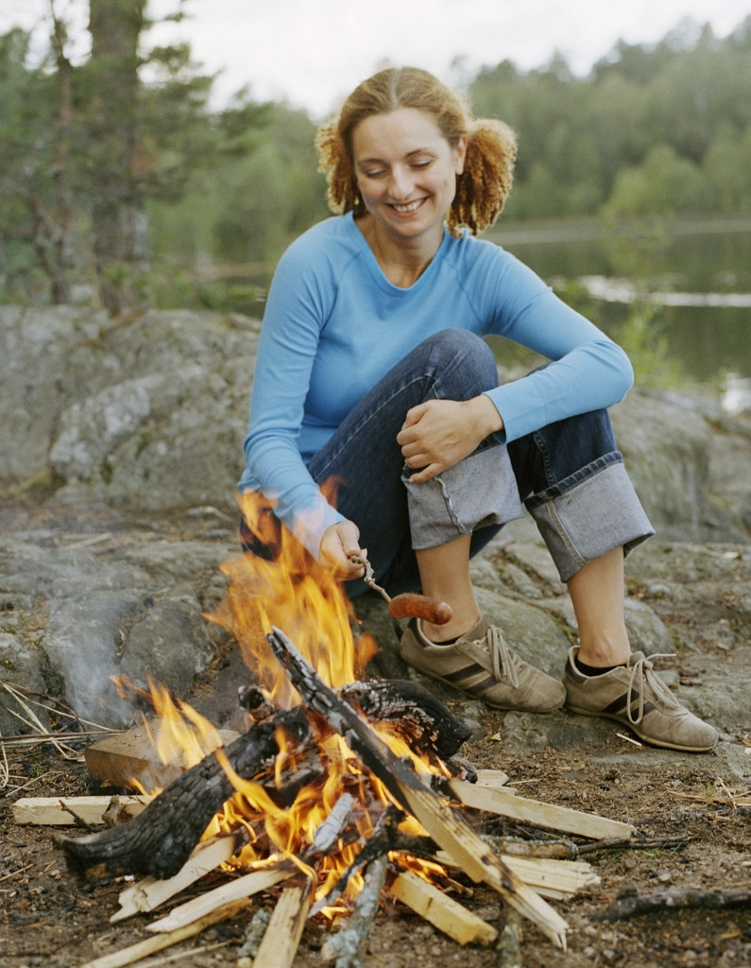  Makara | Relax, cook a few marshmallows and tell a story or joke. Scarf only tonight.
Weekend  26-27/6/10 | Scout Leadership Course | Elanora Scout Hall | All | Makara  Anyone who is 12yrs and over, has been in Scouts for 1 year and has their Pioneer Badge can apply for this course. Only 4 from our troop will be accepted on the course. So first 4 to let me know they want to attend this course are in. | Saturday afternoon and Sunday. The cost is $25 but this will be covered by the Group. Full uniform. Applications need to be in by 5th June.
Thursday  1/7/10 | Iceblocking | Mona Vale | All PLs |   Teddy | First down the hill wins! Scarf only.

