Date | Activity | Location | PL/APL | Leader | Notes
Thursday  25/02/10 | Canoeing | Manly Dam | All PLs | 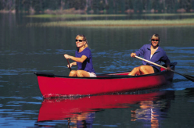  Makara | Cruisy paddle exploring the dam
Thursday  4/03/10 | “River Crossing” Night | Narrabeen | All PLs |   Makara | District event. Learn how to cross waterways and keep your gear dry
Sunday  7/03/10 | Clean up Australia Day | Greendale Creek & surrounds | All PLs | 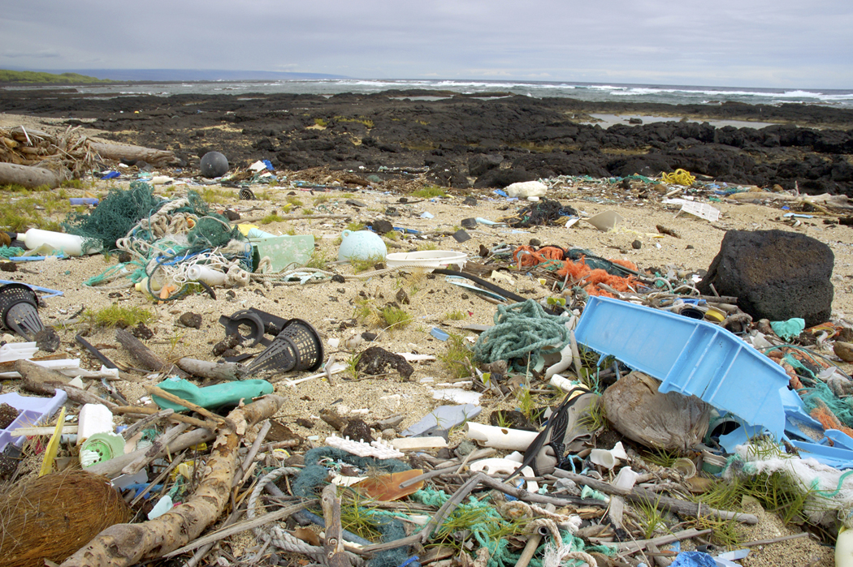  Rock | Make Australia beautiful. Start in your own backyard
Thursday  11/03/10 | Troop Council  Registration night  Environment | Brookvale Hall | Kiri | 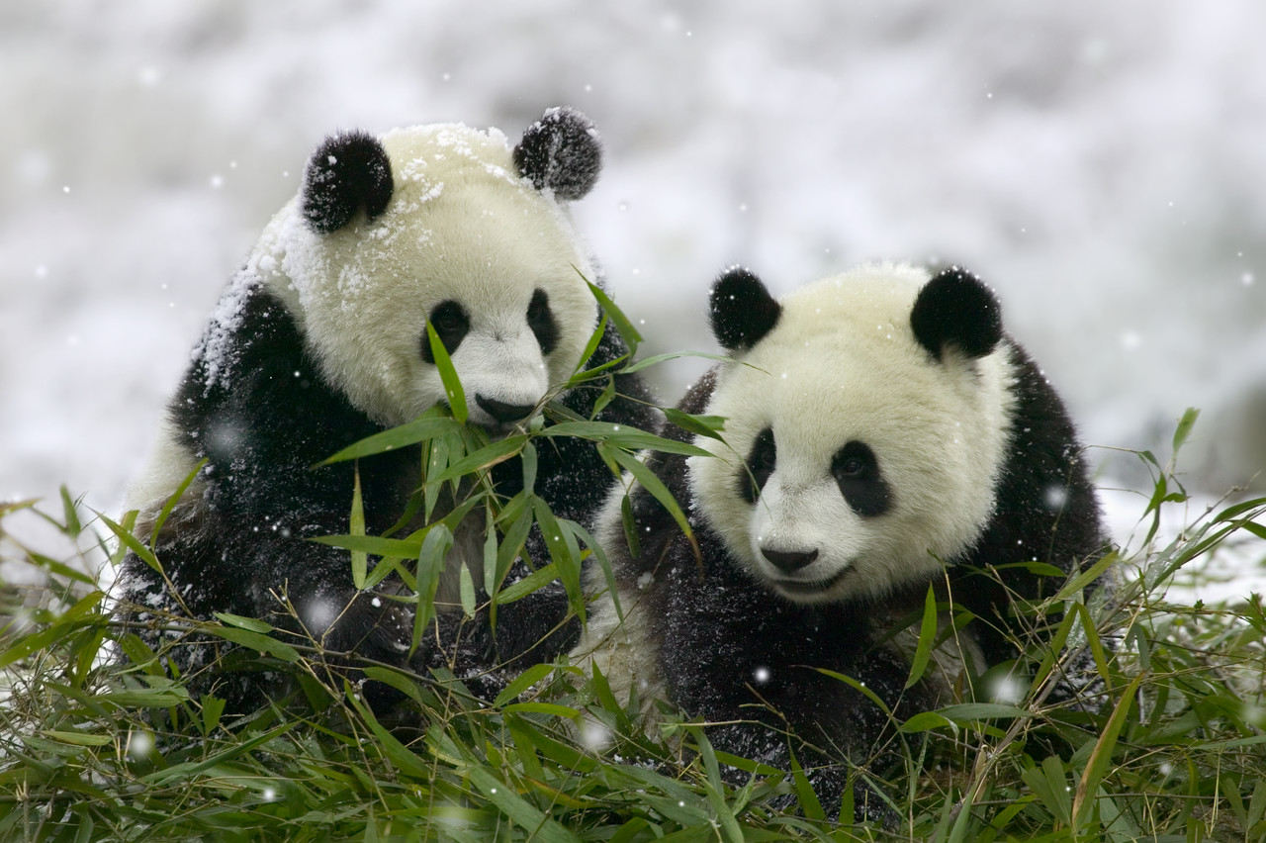  Makara | Troop Council PLs &APLs only
Thursday  18/03/10 | Hike preparation | Brookvale Hall | Jamie |   Ted | Make sure you have everything for your hike
W/E  20 & 21/03/10 | Overnight Hike | Mt Solitarie | All PLs | 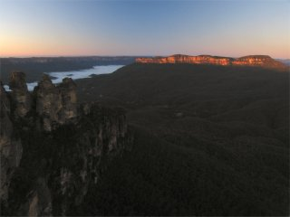  Ted | Yah! We’re off on a hike!  Photo: Mt Solitary at sunrise, from Echo Point
Tuesday  23/03/10 | Early registration for Scout Hike close |  | All PLs
Thursday  25/03/10 | Badge night | Brookvale Hall | Belinda |   Ted | A chance to get all those achievements signed off.
Saturday  27/03/10 | Earth Hour | Curl Curl |  |   Pamela | Group activity
Thursday  1/04/10 | Easter Egg Hunt | Hall | Jamie |   Rock | The best Easter Egg hunt ever!

